Setting up the sensors

We will be using the Arduino Integrated Development Environment to upload code to the Arduino board. Download and install it via this link <https://www.arduino.cc/en/software>

Lets us upload our first program to the board:

Go to Arduino IDE and Open the LED blink example sketch: **File > Examples > 01.Basics > Blink**.

**Select your board type and port**

Select **Tools > Board > Arduino AVR Boards > Arduino Nano**.

### **What is a bootloader?**

The bootloader is the little program that runs when you turn the Arduino on, or press the reset button. Its main function is to wait for the Arduino software on your computer to send it a new program for the Arduino, which it then writes to the memory on the Arduino. This is important, because normally you need a special device to program the Arduino. The bootloader is what enables you to program the Arduino using just the USB cable.

Some Arduino Nano Boards may come with the newer bootloader version, to program the NEW Arduino NANO boards you need to chose **Tools > Processor > ATmega328P**. To program old boards you need to choose **Tools > Processor > ATmega328P (Old Bootloader)**. If you get an error while uploading or you are not sure which bootloader you have, try each **Tools > Processor** menu option until your board gets properly programmed.

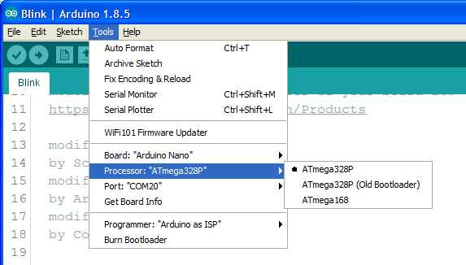

Next we have to select the Port, go to the port tab, some boards are automatically detected,

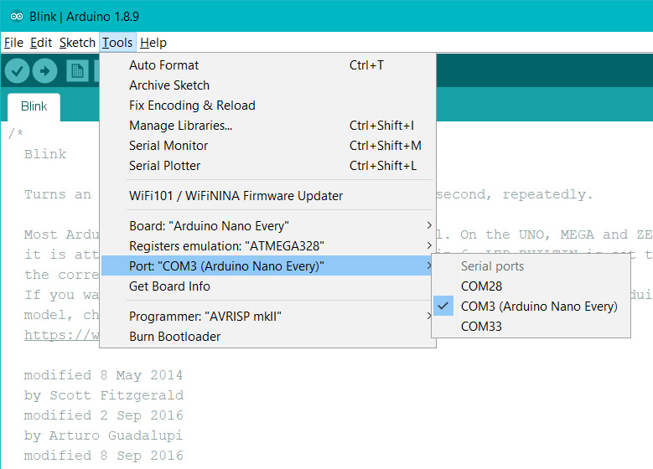

Else we can go to Device manager in windows to find the port

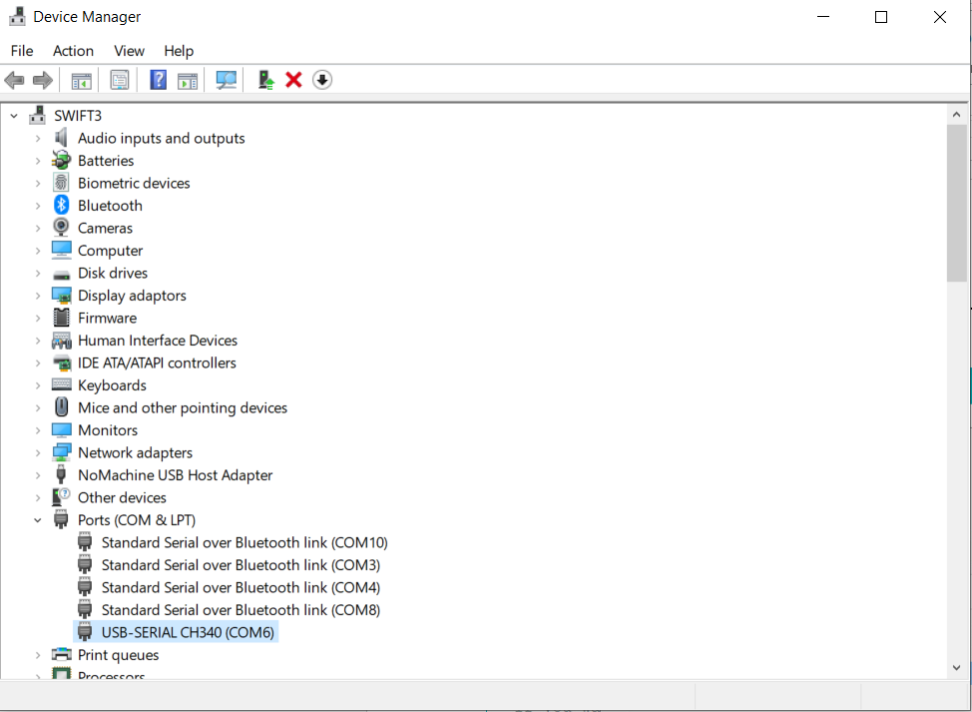

The CH340 is the usb to serial converter present on the Arduino Nano board

#### Upload and Run your first Sketch

To upload the sketch to the Arduino Nano, click the **Upload** button in the upper left to load and run the sketch on your board:

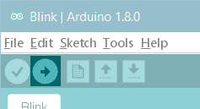

Wait a few seconds - you should see the RX and TX LEDs on the board flashing. If the upload is successful, the message "Done uploading." will appear in the status bar.

For a complete guide on the Arduino IDE go to: <https://create.arduino.cc/projecthub/Arduino_Genuino/getting-started-with-the-arduino-desktop-ide-623be4>

<https://www.arduino.cc/en/Hacking/MiniBootloader>

<https://www.arduino.cc/en/Guide/ArduinoNano>

Installing additional libraries

Open the IDE and click to the "Sketch" menu and then Include **Library** > Manage **Libraries**.

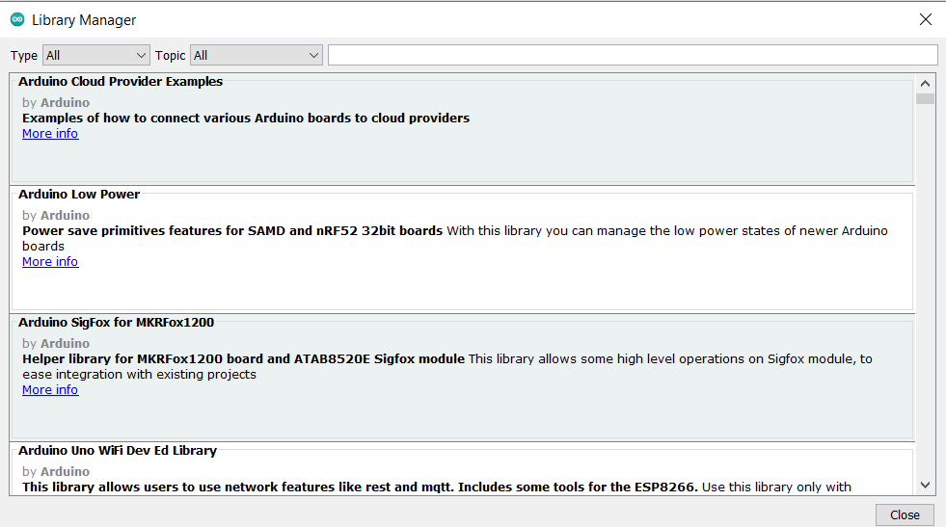

This opens the Library manager we can see existing libraries or search for new libraries to install